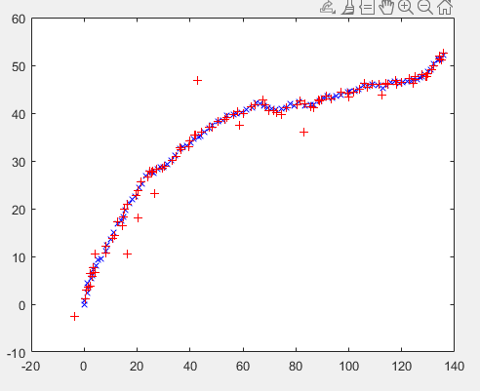

Figure: initial plot values for x and y csv files.

Mean values

nx= 0.0125

ny= -0.1202

standard deviation values

std (nx)= 1.5449

std (ny)= 1.6037

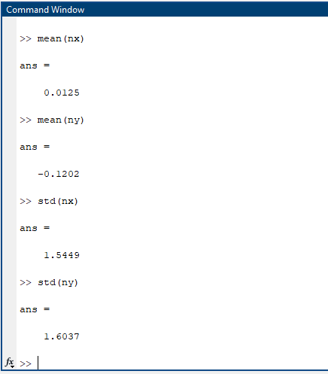

Figure: Mean and standard deviation values obtained for nx and ny.

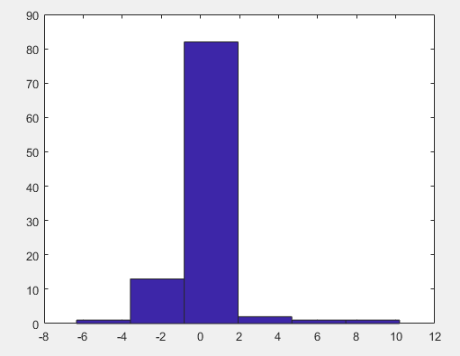

Figure: histogram of nx.

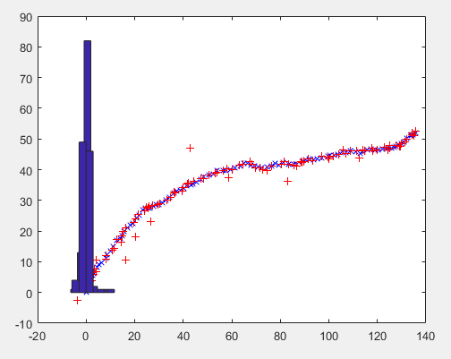

Figure: histogram of nx and ny.

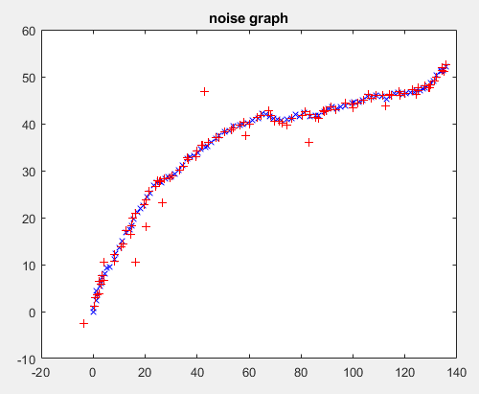

Figure: Noise graph

Task 2) Using kalman filter for noisy version of a and b

Plotting the values for x,y and a,b.

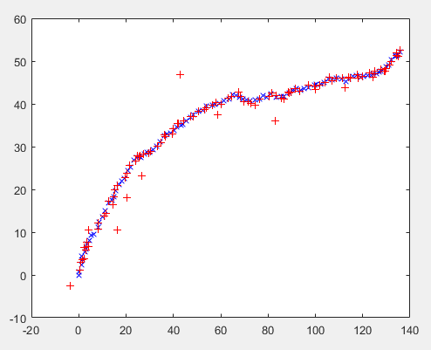

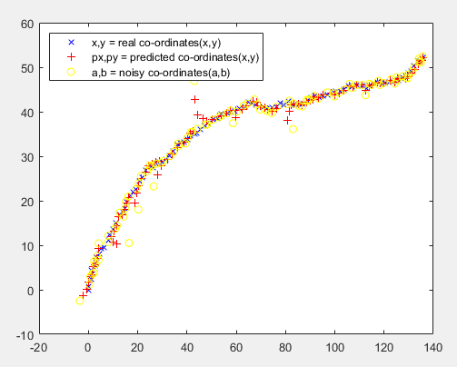

Figure: final comparison of both noisy and estimated co-ordinates of ground truth.

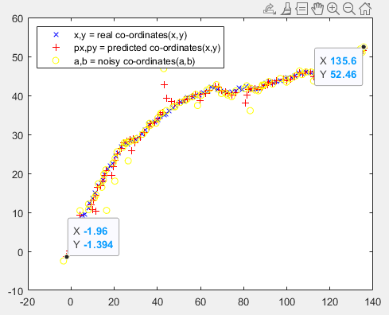

Figure: Plotted with the values.

**Calculating the mean and standard deviation of absolute error and Root mean squared error for estimated value**

Standard_deviation_absolute_error =

Columns 1 through 10

2.4053 1.0749 1.2108 0.6175 1.0551 0.5304 0.4560 0.2869 1.2670 0.9367

Columns 11 through 20

5.3628 1.9391 0.6454 0.4075 0.7004 0.4651 0.6473 0.2465 0.2898 0.9043

Columns 21 through 30

2.5908 0.8866 1.0102 0.4537 0.3128 0.4222 0.7920 0.9588 0.6668 0.3174

Columns 31 through 40

3.5283 2.2580 0.9481 0.6356 0.6134 0.4853 0.0758 0.2496 0.5256 1.0061

Columns 41 through 50

7.5213 3.4893 1.5893 0.3723 0.3821 0.3957 0.4087 0.5971 0.4130 0.4712

Columns 51 through 60

2.3389 1.2956 1.1722 0.4262 0.7607 0.4148 0.7137 0.4155 0.8191 0.5450

Columns 61 through 70

4.9231 2.4130 1.3064 0.2530 0.1498 0.4194 0.3280 0.6874 0.4536 0.4055

Columns 71 through 80

3.9725 2.0580 1.1355 0.9655 0.4214 0.2847 0.1545 0.4418 0.0266 0.3898

Columns 81 through 90

0.5810 0.0770 0.8634 0.1380 0.6768 0.2507 0.4129 0.7438 1.2331 0.2923

Columns 91 through 100

1.9200 1.1469 0.5782 0.5190 0.5812 0.8339 0.3839 0.7147 0.4934 0.1747

**Root_mean_standard_error =**

**1.5204**

Calculating the mean and standard deviation of absolute error and Root mean squared error for Noisy value

Standard_deviation_absolute_error_NOISY =

Columns 1 through 13

4.2636 0.5137 0.7959 0.7844 0.8944 0.9444 0.2816 0.4697 1.4575 1.5510 10.2403 0.3538 0.6284

Columns 14 through 26

0.6990 0.5912 0.4956 1.0521 0.0510 0.3094 0.8707 4.5120 0.2391 0.6860 0.6055 0.6874 0.5310

Columns 27 through 39

0.5084 1.0818 0.3014 0.6191 6.4902 1.1163 0.4496 0.0742 0.5679 0.8979 0.5315 0.3437 0.7608

Columns 40 through 52

1.1415 11.6937 1.1958 0.2532 0.4300 0.0862 0.5469 0.5241 0.2055 0.4691 0.6988 4.0858 0.4249

Columns 53 through 65

0.7968 1.0869 0.3714 0.7229 0.8198 0.5204 1.2074 0.1942 7.6873 1.0126 0.4243 0.2607 0.3840

Columns 66 through 78

0.5922 0.2197 0.8393 0.3761 0.4539 6.4437 0.5935 0.3064 1.3565 0.2452 0.4491 0.6114 0.2732

Columns 79 through 91

0.0703 0.3621 1.6389 0.5503 1.2227 0.3173 1.0508 0.3736 0.9207 0.8770 1.0939 0.5504 2.8156

Columns 92 through 100

0.3491 0.5019 0.2324 0.4271 0.4371 0.6085 0.5237 0.3538 0.4596

**Root_mean_standard_error_NOISY =**

**2.2189**

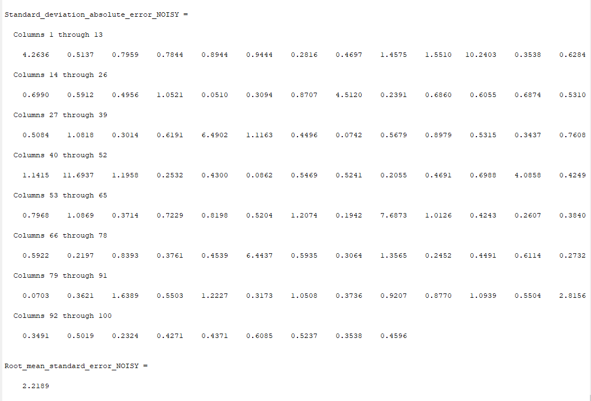

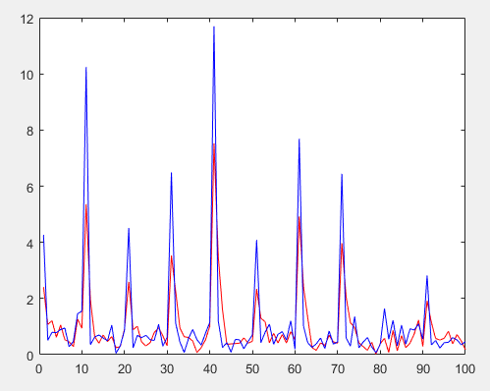

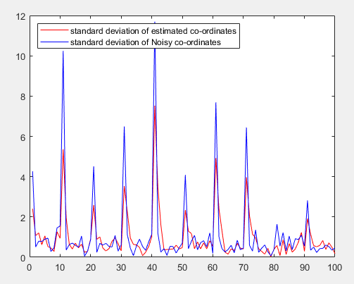

Figure: Plot for comparing both noisy and estimated co-ordinates of ground truth values.

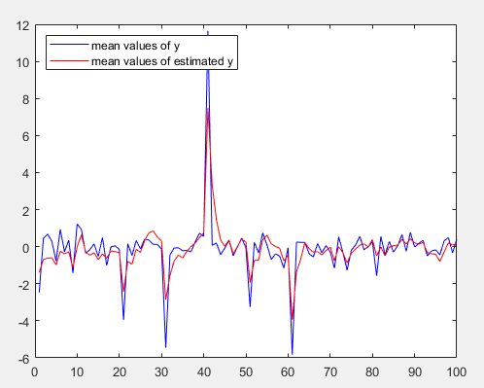

Figure: mean values of y and mean values of estimated y.

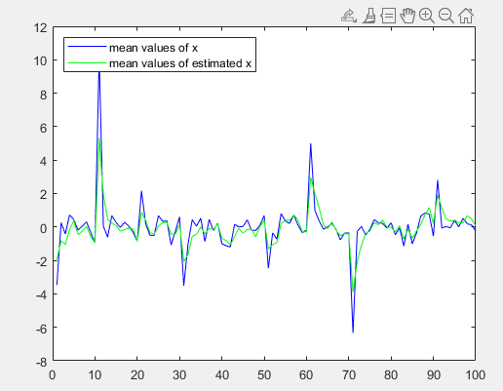

Figure: mean values of x and mean values of estimated x.

Final plot with gating

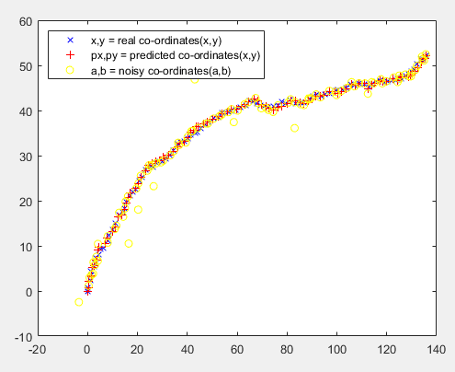

Figure:Final plot with gating